Industrial, Manufacturing, & Systems Engineering
College of Engineering

Systems Engineering Project Practicum
Summary
Project Title: | NUBASE Requirements and Reviews Process
Team members: | 1. Priscila, Gomez  2. Lorenzo, Luevano  3. Luis, Oliva  4. Heidy, Seo  5. Antonio, Zuñiga
Semester, year: | Fall 2017
Type of project: | Individual project at students work ( )  Team project assigned by instructor (x)  Project proposed by team ( )

Insert Individual / team PICTURE HERE

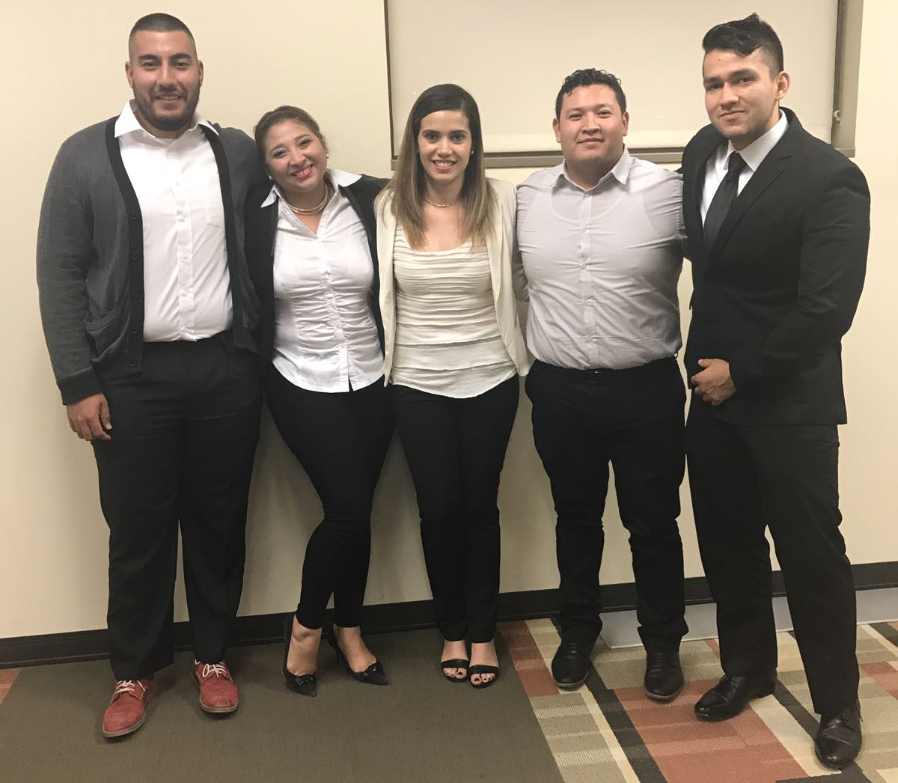

Lorenzo Luevano, Heidy Seo, Priscila Gomez, Luis Oliva & Antonio Zuñiga

INTRODUCTION
The System Engineering Project Practicum provides the opportunity to apply System Engineering concepts in developing a real system and create documents that formally describe the system. Students review documents and validate them with clients and customers through formal presentations. Teams are self-managed and assign roles to control planning, quality, requirements, design, and implementation.

System Overview
The purpose of this project is to provide NUBA a structured requirements process along with a well defined review process.
Currently NUBA lacks of these two processes and they rely in informal activities that produce issues and defects. Usually these defects are found on the final phases of the lifecycle and by then they are extremely expensive to correct.
The NUBASE project addresses these issues by providing a well tailored process to gather the requirements for a new system or module. To ensure that these requirements meet all customer expectations and defect as detected as early as possible a review process is produced as well.

System Description
The NUBASE project establishes a process to derive and decompose the business requirements into system and top level requirements. These process is accompanied by the review process that places checkpoints to the requirements process in order to guide it to succes.

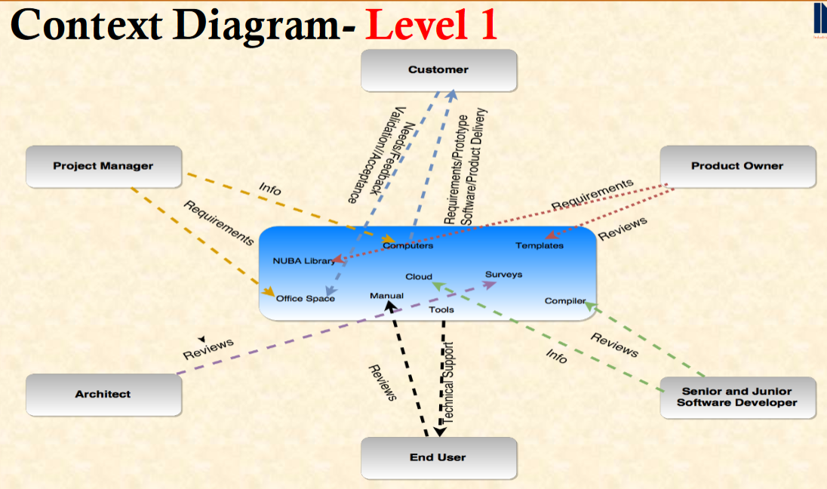

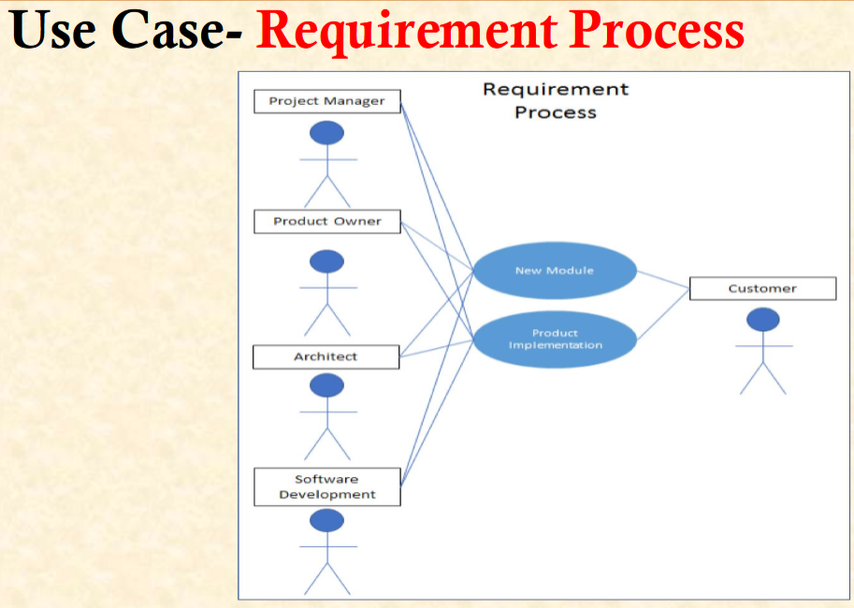

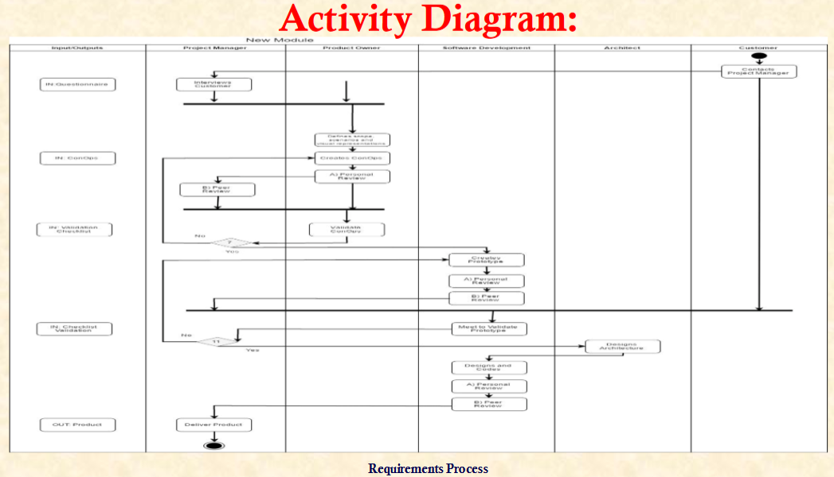
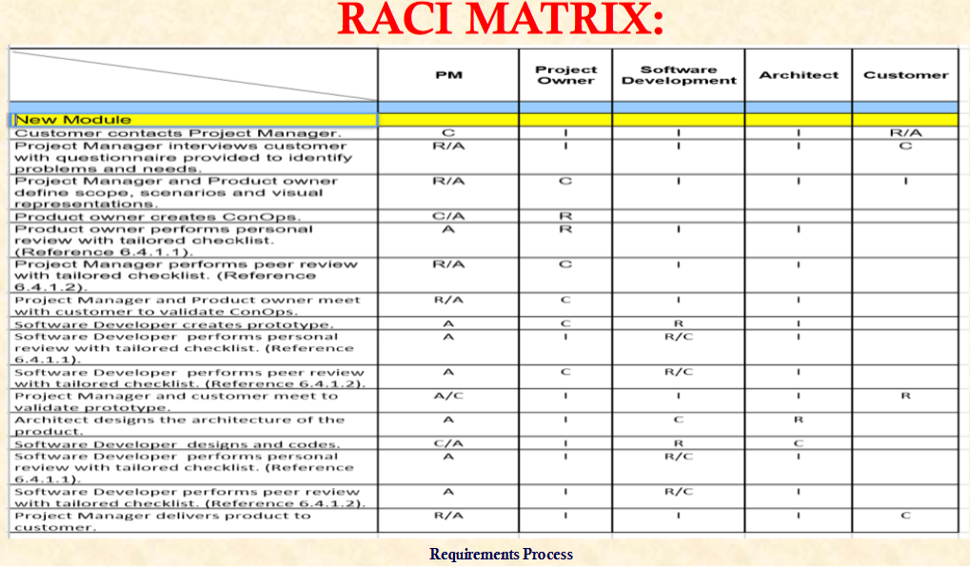
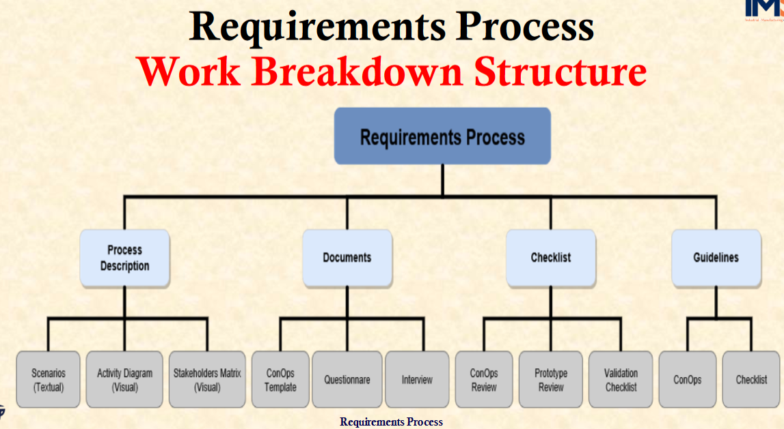
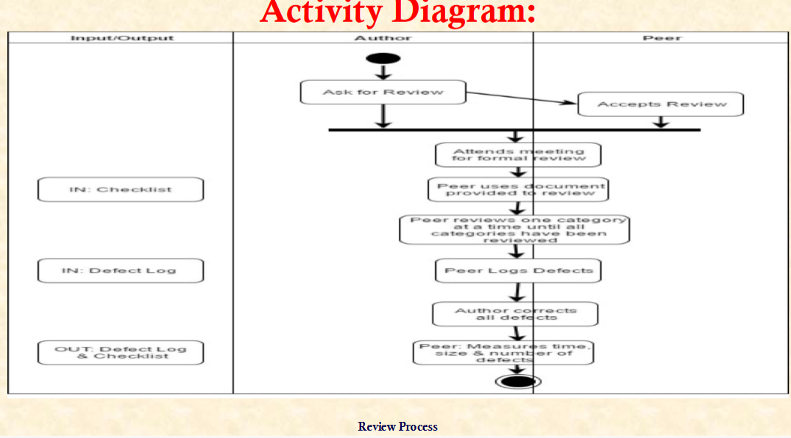

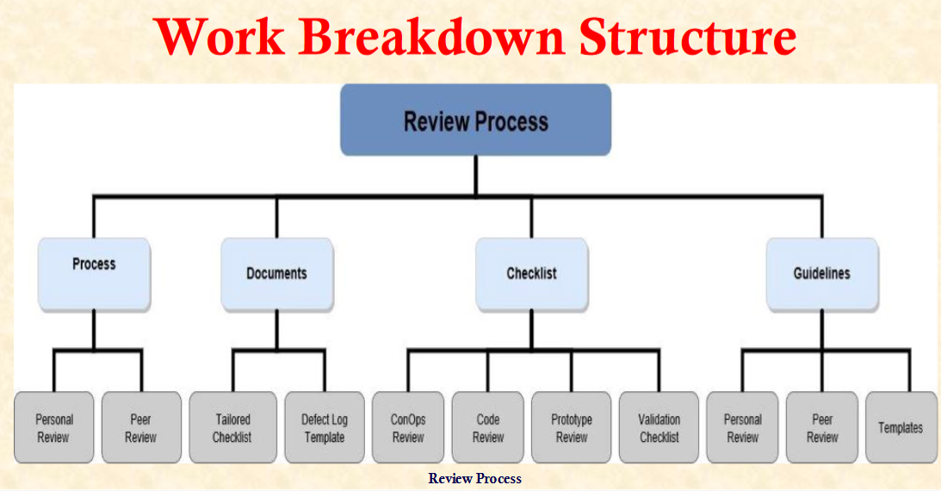
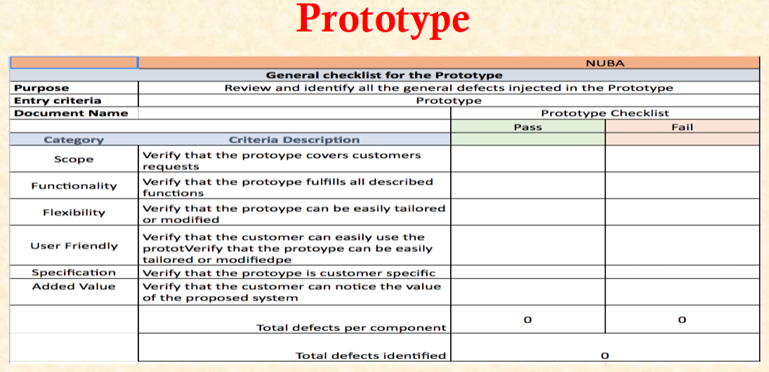

List of Actors

- Project Manager
- Product Owner
- Architect
- Software Development Team
- Peer
- Author

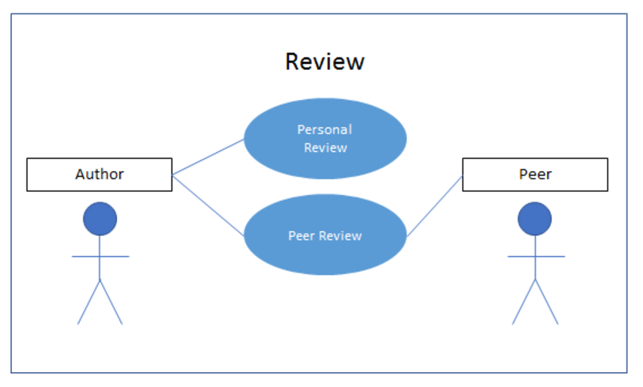
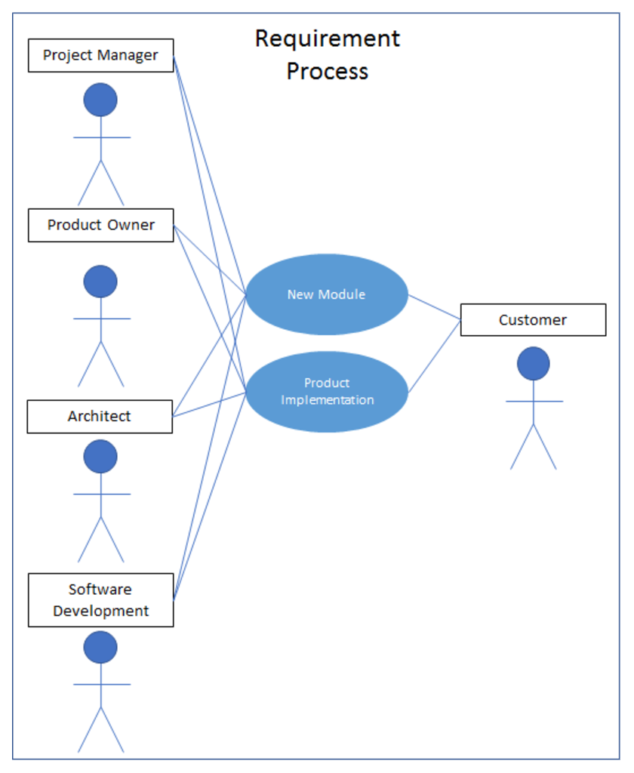
Activity Diagrams

PROJECT OUTCOMES
With the employment of these processes NUBA will be able to successfully derive system requirements that meet all stakeholder needs and defects will be immediately found reducing the fixing cost.

The quality of the system will greatly increase since a high percentage of the defect will be detected.
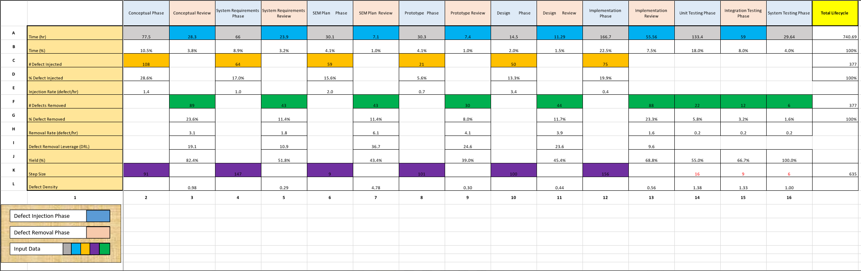

In order to develop these processes our team had to rely on internal communication and teamwork to come up with the best possible solution for NUBA.

MASTERS OF SCIENCE IN SYSTEM ENGINEERING PROGRAM ASSESSMENT
- Requirements Specification
- Validation & Verification Techniques
- Personal & Peer Reviews
- Process Management
- Project Management
- Agile Methodologies
- INCOSE Regulations
- CMMI Regulations

While completing our systems engineering degree we meet with several companies that were looking to hire systems engineering students. Companies like Lockheed Martin, Freeport McMoran and General Motors. These interactions proved to be fruitful and two people from our team were given a job offer from Lockheed Martin. Heidy Seo received a job offer from Lockheed Martin in Sunnyvale California. Luis Oliva received a job offer from Lockheed Martin as well but on the Littleton Colorado Facilities.

